Item-Specific and Relational Encoding, but not Warnings, are Effective at

Reducing the Illusion of Competence

Emily E. Cates, Nicholas P. Maxwell, & Mark J. Huff

The University of Southern Mississippi

**Author Note**

Correspondence concerning this article can be addressed to Mark. J. Huff, School of Psychology, The University of Southern Mississippi, 118 College Dr. #5025, Hattiesburg, MS 39406, United States. Study materials and analyzed data are available via OSF (osf.io/k73r4). This study was completed as part of the Honors Thesis requirements for EEC.

Email: mark.huff@usm.edu

Abstract

Metamemory, or the ability to understand the capacities of one’s own memory, is an important part of the learning process. One method for assessing metamemory is through the Judgment of Learning (JOL) task in which participants are asked to judge the likelihood of correctly remembering a target word in a cue-target word pair when only presented with a cue word at test. The associative direction of the cue-target pair has been shown to affect the accuracy of JOLs. Unlike forward pairs (e.g., credit-card) in which JOLs accurately predict recall, an illusion of competence has been reported for backward associates (e.g., card-credit), symmetrical associates (e.g., salt-pepper), and unrelated pairs (e.g., artery-bronze) in which JOLs overestimate later recall. The present study evaluates whether the illusion of competence pattern can be reduced when participants use an item-specific or relational encoding strategy relative to reading (Experiment 1), and whether these encoding tasks are aided by warning participants about the illusion (Experiment 2). Across experiments, item-specific and relational encoding were found to reduce the illusion of competence for backward and unrelated pairs; however, warnings did not improve JOL estimations. Thus, the method of encoding, but not warnings, can facilitate JOL accuracy for backward and unrelated pairs.

Word count: 201

*Keywords:* Judgements of Learning; Illusion of Competence; Item-Specific Encoding; Relational Encoding; Warnings

Item-Specific and Relational Encoding, but not Warnings, are Effective at

Reducing the Illusion of Competence

Successfully monitoring the progress of one’s learning is paramount for improving retention when studying information. Effective monitoring allows individuals to adjust their encoding strategies to maximize later retention (Nelson & Narens, 1990). Metamemory judgments, or having individuals judge or estimate the effectiveness their memorial abilities, can be used to obtain information about an individual’s knowledge of learning process. A common method used to gauge metamemory knowledge is the Judgment of Learning (JOL) task. In a standard JOL task, individuals study a set of cue-target word pairs and are asked to estimate the likelihood that they will be able to recall a target word when only provided with the cue on a later memory test. These estimates can be elicited using several types of measurement scales such as Likert scales or binary “yes-no” responses (Hanczakowski, Zawadzka, Pasek, & Higham, 2013), however, JOLs are often elicited using a continuous 0 to 100 scale representing the percent likelihood that the target item will be successfully recalled at test (e.g., 100% = definitely would remember; 0% = definitely would not remember). The use of a 100-point scale is beneficial as it allows for a straightforward comparison between predicted target recall (via JOLs) and the percentage of targets that are correctly recalled at test.

Although JOL ratings can be highly predictive of later recall (i.e., well-calibrated), several factors can affect the efficacy of JOLs. These include perception of identical cue-target word pairs as being fluent due to word repetitions (Castel, McCabe, & Roediger, 2007), increasing the time spent studying word pairs (Koriat & Ma’ayan, 2005), and the direction and strength of the relatedness between the cue-target study pairs (Koriat & Bjork, 2005; Maxwell & Huff, in press). The present study further examines factors that affect the accuracy of JOLs by examining the associative direction between cue-target pairs (i.e., probability that the cue word elicits the target at test or vice versa) and by testing whether encoding tasks that emphasize the shared or distinctive characteristics of the word pairs through relational and item-specific encoding tasks, respectively, can improve the accuracy of JOLs in predicting later recall.

Interest in the relationship between memory predictions and accuracy is not new. In an early example, Arbuckle and Cuddy (1969) asked participants to study paired letter-number pairs (e.g. A-73) and report whether they would or would not remember the pairs on a later test. At test, participants also provided a postdiction that they were either correct or incorrect regarding their answer. Overall, Arbuckle and Cuddy reported that participants correctly predicted later recall for an average of 67% of trials and correctly postdicted their responses for 88% of trials, leading the authors to conclude that participants had insight into how difficult each pair would be to remember and adjusted their predictions accordingly based on the association between participants’ predictions and subsequent recall.

More recently, Koriat and Bjork (2005) have shown that the associative relationship between the cue-target pairs, such as the direction and the strength of the relationship, can affect JOL accuracy. Specifically, the authors delineated between types two types of associations thought to influence the relationship between JOLs and recall. First, *a priori* associations refer to associations in the forward direction (e.g., credit-card, stork-baby). The strength of these pair types is rooted in the likelihood that the cue word will elicit the target word at test. A priori/forward association strength can be readily assessed through the use of free association norms (e.g., The University of South Florida Free Association Norms; Nelson, McEvoy, & Schreiber, 2004; The Small World of Words Project; De Deyne, Navarro, Perfors, Brysbaert, & Storms, 2019). These norms are generated via free association tasks in which participants are provided with a single cue word and are asked to respond with the first target word that comes to mind. These norms can then be used to compute the probability of responding to word A with word B (i.e., forward associative strength, FAS). Separately, *a posteriori* associations refer to the perceived relatedness between pairs that are only apparent to participants when words are presented together. These pairs can refer to weakly associated pairs (e.g., article-newspaper) or strong associates in which the pair order has been flipped (i.e., backward pairs, card-credit, baby-stork). Similar to a priori pairs, free association norms can be useful for indexing the backward associative strength (BAS) between pairs (i.e., the probability of responding to word B with word A in an A-B item pairs; see Nelson, McEvoy, & Dennis, 2000 for a review). Thus, a posteriori pairs could have either weak levels of FAS or strong levels of BAS.

To test the correspondence between JOLs and recall for a priori and a posteriori pairs, Koriat & Bjork (2005) evaluated JOL accuracy when participants studied unrelated and a priori study pairs (e.g., strong forward associates; Experiment 1), a priori and a posteriori pairs (e.g., backward associates; Experiment 2), and unrelated pairs, a priori pairs, and semantically related a posteriori pairs that shared no association based on the norms (Experiment 3). Across experiments, a posteriori pairs showed an *illusion of competence* pattern in which JOLs exceeded subsequent recall rates, indicating that participants were overpredicting the likelihood that they would later recall the target word. This pattern was particularly robust for a posteriori backward pairs, as the cue word, when presented in isolation, does not directly converge upon the target word. Thus, although participants predict that backward pairs are highly likely to be recalled, recall accuracy is typically much lower than predicted.

The illusion of competence pattern found with a posteriori and backward pairs has similarly been reported by Castel et al. (2007) who examined the correspondence between JOLs and subsequent recall when participants studied and provided JOLs for strongly and weakly related forward associates, unrelated items, and identical cue-target word pairs. Overall, an illusion of competence emerged for identical word pairs in which JOLs exceeded subsequent recall rates. The authors ascribed this pattern to the identical pairs being easier to learn relative to both forward and unrelated pairs given identical pairs were repeated items. As a result, participants may not have encoded identical pairs as deeply because they thought they would be easier to recall given the cue word was perfectly predictive of the target.

More recently, Maxwell and Huff (in press), further investigated the correspondence between JOLs and recall rates by looking at symmetrical associates (e.g., on-off), relative to forward, backward, and unrelated pairs. Symmetrical pairs differ from forward and backward pairs in that the associative strength between the cue and target word are equivalent in both directions(i.e., on-off would have the same associative strength as off-on), whereas for forward and backward pairs the association is stronger is one direction than the other (i.e., tuna-fish is strongly associated in the forward direction, but has a weaker association in the backward direction, fish-tuna Across four experiments, Maxwell and Huff (in press) found a robust illusion of competence pattern for backward pairs and, additionally, the illusion of competence was shown to extend to symmetrical associates, suggesting that the bidirectional association found for symmetrical pairs is not sufficient for the cue word to regularly illicit the target word. Maxwell and Huff (in press) also suggested that participants may be using both the forward and backward associations when studying the symmetrical pairs even though only the forward association would be beneficial at test. These findings indicate that the associative direction of a word pair can affect JOL accuracy, even when associative strength is matched across pair types.

An additional contribution of Maxwell and Huff’s (in press) study was they incorporated sets of calibration plots in which JOL ratings for pairs were rounded to each 10% interval, and then were plotted against their corresponding recall accuracy (see Nelson & Dunlosky, 1991). Calibration plots are useful because they provide qualitative information regarding specific JOL ratings where participants are well-calibrated (i.e., pairs given a 40% JOL rating should be correctly recalled 40% of the time, pairs with a 60% ratings are recalled 60% of the time, etc.), compared to those ratings that are not. Across experiments, Maxwell and Huff found that forward and symmetrical pairs were generally well-calibrated at JOL ratings below 80%, but for backward and unrelated pairs, an illusion of competence pattern emerged at JOL ratings greater than 30%. Thus, the calibration plots revealed that an illusion of competence pattern emerged for all pair types, however this pattern was only found at the highest JOLs for forward and symmetrical pairs but occurred at much lower JOL ratings for backward and unrelated pairs.

Given that the illusion of competence can be found diffusely across all pair types depending upon the JOL rating, the goal of the present study was to examine methods that could potentially improve the accuracy of JOLs on subsequent recall and thereby reduce the illusion of competence. One such method, tested in Experiment 1, is by having participants engage in different types of encoding strategies that may help or hinder the processing of the relationship between the cue-target pair, a discussion with which we now turn.

**Item-Specific/Relational Processing on Memory Performance**

Memory researchers have long known that certain study tasks are more successful at improving retention than others. The levels-of-processing framework classifies tasks that promote elaborative processing of studied items that typically promotes memory as “deep” tasks, while less successful tasks that focus on surface or perceptual features of study items as “shallow” tasks (Craik & Lockhart, 1972; Craik, 2002). Several deep tasks have been identified, including generation (Slamecka & Graf, 1978), production (MacLeod, Gopie, Hourihan, Neary, & Ozubko, 2010), and survival processing (Nairne, Thompson, & Pandeirada, 2007), however deep tasks can be bifurcated further based on a task’s propensity to encourage the processing of item-specific or relational features.

According to the item-specific/relational processing framework (Einstein & Hunt, 1980; Hunt & Einstein, 1981), encoding tasks differ in the likelihood that they can encourage the processing of unique features of study items through item-specific processing, or through the processing of shared characteristics of study items via relational processing. Thus, item-specific processing entails having participants focus on the unique features of items at study (e.g., for the pair cat-turtle, cats are mammals and turtles are reptiles, cats have fur, turtles have shells, etc.), while a relational task has participants focus on the shared features (e.g., cats and turtles are animals, both can be kept as pets, etc.). These types of processing qualitatively affect encoding strategies by changing how information encoded. Many studies have found differential memory benefits for item-specific and relational encoding tasks. For example, McCurdy, Sklenar, Frankenstein, and Leshikar (2020), showed that relational processing facilitated the generation effect for lower-constraint tasks (i.e. generating a target word in the presence of a cue) potentially because participants had to create a relationship between the two words. Relational processing could therefore be beneficial in studying unrelated word pairs since there is no existing relationship between the words. Separately, Huff and Bodner (2014) found that item-specific tasks were more likely to improve recall and recognition when study items were strongly related, but not when study items were weakly related. Similarly, relational tasks were more likely to improve recall and recognition when study items were weakly than strongly related (argued to be evidence for encoding variability of processing). Thus, although item-specific and relational processing tasks are generally classified as “deep” tasks according to the levels-of-processing framework, their relative memory benefits are affected by the association between study materials.

Given the interactive benefits of item-specific and relational encoding with different associative materials, the present study tested whether these encoding strategies can improve the calibration between JOLs and later recall, especially on backward and unrelated pairs in which the illusion of competence is robust (Castel et al., 2007; Koriat & Bjork, 2005; Maxwell & Huff, in press; Soderstrom, Clark, Halamish, & Bjork, 2015). Specifically, Experiment 1 compares JOLs and cued-recall performance for groups of participants who either encode cue-target pairs using either item-specific or relational tasks relative to a standard read-only control task across forward, backward, symmetrical, and unrelated pair types. In Experiment 2, we then examined whether tests whether combining item-specific and relational tasks with an explicit warning about the illusion of competence could further reduce the illusion of competence and improve JOL calibration. Finally, in both experiments, we follow analyses used by Maxwell and Huff (in press) by plotting participants JOL ratings against their recall rates using a series of calibration plots to examine specific JOL ratings where participants may over/under predict subsequent recall.

**Experiment 1: Item-Specific Versus Relational Encoding Instructions**

The goals of Experiment 1 were twofold. First, this experiment sought to replicate the illusion of competence for backward, symmetrical, and unrelated pairs for participants completing the silent reading task. Next, we tested whether item-specific/relational encoding tasks could reduce the illusion of competence by either lowering JOL ratings, increasing correct recall, or both. Overall, it was expected that having participants engage in item-specific/relational encoding tasks would reduce the illusion of competence by improving correct recall relative to the control group. Additionally, because relational encoding encourages participants to generate an association between cue-target pairs, it was expected that this encoding manipulation would be beneficial across pairs given only the cue-word is available at test, but particularly beneficial for backward and unrelated pairs where the cue is less effective at prompting target retrieval. Finally, because item-specific (vs. relational) processing has been shown to be more beneficial to memory when pairs are related (Huff & Bodner, 2014), it was expected that this encoding strategy would be most beneficial for improving JOL calibration and reducing the illusion of competence for backward and symmetrical pairs. Thus, the qualitative differences in item-specific and relational encoding were expected to produce differential benefits on improving JOL calibration depending on the pair type that was studied.

**Methods**

**Participants**

Eighty-eight University of Southern Mississippi undergraduates participated for partial course credit. Participants were randomly assigned to either the item-specific encoding group (*n* = 29), the relational encoding group (*n* = 31), or the read-only control group (*n* = 28). All participants were native English speakers with normal or corrected-to-normal vision. . A sensitivity analysis using *G*Power* (Faul, Erdfelder, Lang, & Buchner, 2007) indicated that the sample had sufficient power (.80) to detect a small-to-medium effect size (Cohen’s *d* = 0.27) or larger.

**Materials**

Stimuli included 180 associative word pairs initially used by Maxwell and Huff (in press). Pairs were taken from the University of South Florida Free Association Norms (Nelson et al., 2004). These consisted of 40 forward pairs (e.g., credit-card), 40 backward pairs (e.g., card-credit), 40 symmetrical pairs (e.g., salt-pepper), 40 unrelated pairs (e.g. art-lion), and 20 weakly related, non-tested buffer pairs used to control for primacy and recency effects. Pairs were divided evenly into two study blocks, each containing 20 forward, backward, symmetrical, and unrelated pairs and 10 buffer pairs, for a total of 90 pairs in each list. All participants saw both lists presented in separate study-test blocks, the order of which was counterbalanced across participants. Each list began and ended with five buffer pairs, with the other pairs randomized anew for each participant.

Pair types were equated on associative strength (i.e., FAS and BAS) using the Nelson et al. (2004) free-association norms (Table 1). Additionally, these pairs were designed to control for lexical and semantic properties that could potentially influence recall rates, including word length, SUBTLEX frequency (Brysbaert & New, 2009), and concreteness values from derived from the English Lexicon Project (Balota et al., 2007; Maxwell & Huff, in press; Table 2). Further, the two study blocks were matched on each of these properties. Thus, mean associative overlap and lexical/semantic properties were equivalent between direction types and study blocks. Finally, counterbalanced versions of the study lists were created that switched the order of the word pairs (i.e., forest-tree vs. tree-forest). As a result, forward pairs from one counterbalance became backward pairs on another and vice versa. Alternating pair direction allowed for greater control of item differences, particularly on forward and backward pairs, as the same items were used in the forward and backward directions across counterbalances. Pair order was similarly flipped and counterbalanced across unrelated and symmetrical pairs.

The cued-recall test in each block contained all 80 cue words from the studied pairs minus the buffer pairs which were not tested. The cue word was shown next to a question mark that had replaced the target word. The order of the test was randomized anew for each participant.

**Procedure**

The experimental procedure followed of the general procedure used by Maxwell and Huff (in press). All participants completed the study individually on computers using *E-Prime* 3 software (Psychology Software Tools, Pittsburgh, PA). Participants were randomly assigned to one of three encoding groups: A read-only control, item-specific encoding, or relational encoding. For each study group, participants were instructed that they would study a series of cue-target word pairs and that their memory for the target word in these pairs would be tested later with the cue word present. The cue word was always presented on the left and the target on the right. Participants were instructed to rate (via JOL) how likely they were to remember the target word if they were only presented with the cue at test. JOL ratings were made using a 0 to 100 scale, with 0 being “I am certain I WILL NOT REMEMBER the word pair” and 100 being “I am certain I WILL REMEMBER the word pair.” Participants were also instructed to use the full range of the scale to help reduce anchoring on the ends of the scale.

For the read group, participants were instructed to study the word pairs by reading them silently to themselves. For the relational group, participants were instructed to study the word pairs by thinking about how the pair of words were related to each other. Relational participants were also given the example of the word pair “Cat-Turtle”, and how they might think about how cats and turtles are both animals and can both be pets. For the item-specific group, participants were instructed to study the word pairs by thinking about how the words in each pair were unique with the example that for the pair “Cat-Turtle”, participants might think about how cats have fur, but turtles have shells and how cats are mammals, but turtles are reptiles. Participants only saw one type of task instruction. After the encoding instructions, participants completed a ten-word practice set. Participants were then given their first block of word lists to study at their own pace and provided their JOL ratings while the word pair was displayed.

After the first study block was completed, participants were given two minutes to complete an arithmetic filler. Participants then completed a cued-recall task in which only the cue word was presented and were asked to provide the target word from memory. Participants were encouraged not to leave test answers blank and to try their best to retrieve the target word from memory. After the first cued-recall test was finished, participants completed a second study/test block using the same encoding instructions as the first. Once participants completed the second study/test block, they were debriefed and granted participation credit. Participants typically completed the experiment in under 1 hour.

**Results**

Prior to conducting analyses, data were screened for missing responses and outliers (i.e., JOLs outside of the 0-100 range). Recall responses that were skipped were scored as incorrect. A liberal criterion for scoring correct items was adopted such that misspellings or pluralizations were scored as correct. All analyses were collapsed across block (see the supplemental section for analyses split by block). Partial-eta squared (*η*p2) and Cohen’s *d* eﬀect sizes were included for signiﬁcant analyses of variance (ANOVAs) and *t*-tests, respectively. For all analyses, a *p* < .05 signiﬁcance level was used unless noted otherwise. For non-significant comparisons reported, we further analyzed the strength of the evidence supporting the null hypothesis using a Bayesian estimate (Masson, 2011; Wagenmakers, 2007). In this analysis, a model that assumes an effect is compared to a model that assumes a null effect and yields a probability estimate that the null hypothesis is retained (termed *p*BIC; Bayesian Information Criterion). The *p*BIC estimate is advantageous in that it is sensitive to sample size, increasing confidence in null effects reported. This Bayesian analysis is therefore supplementary to null effects detected with standard null-hypothesis-significance testing.

Mean JOL and recall rates as a function of pair type are reported in Figure 1. A 2 (Measure: JOL vs. Recall) × 3 (Encoding Group: Item-Specific vs. Relational vs Read) × 4 (Pair Type: Forward vs. Backward vs. Symmetrical vs. Unrelated) mixed ANOVA evaluated differences between mean JOL ratings and recall rates across the four pair types across the three encoding groups. An effect of measure was found, *F*(1, 85) = 18.79, *MSE* = 694.46, *η*p2 = .07, such that overall, JOL ratings exceeded later recall rates (62.66 vs. 54.19), *t*(87) = 4.18, *SEM* = 2.06, *d* = 0.60. An effect of encoding group was also found, *F*(2, 85) = 5.40, *MSE* = 814.98, *η*p*2* = .05, in which JOL ratings/recall rates were significantly higher for the relational (61.44) and item-specific (60.12) groups relative to the read-only group (53.33). All comparisons differed significantly, *t*s ≥ 2.96, *d*s ≥ 0.78, except for the relational and item-specific groups, which were equivalent, *t* < 1, *p*BIC = .87. Finally, an effect of pair type was found, *F*(3, 255) = 766.58, *MSE* = 107.66, *η*p2 = 0.58, in which JOL ratings/recall rates were higher for symmetrical pairs (74.22), followed by forward pairs (72.29) backward pairs (59.60), and unrelated pairs (27.55). Comparisons across all pair types differed statistically, *t*s ≥ 2.69, *d*s ≥ 0.17.

A significant two-way interaction between measure and pair type confirmed that the illusion of competence replicated across encoding groups, *F*(2, 85) = 5.21, *MSE* = 107.66, *η*p2 = 02. Critically, however, a significant three-way interaction was found, *F*(6, 255) = 15.56, *MSE* = 87.42, *η*p2 = .04, in which the magnitude of the illusion of competence differed as a function of encoding group (See Figure 1 for comparison across encoding groups).

Starting with backward pairs, reliable illusion of competence patterns were found across the three encoding groups, though at different rates. A robust illusion of competence was detected in the read group in which JOLs greatly exceeded later recall accuracy (68.58 vs. 37.78), *t*(27) = 9.44, *SEM* = 3.41, *d* = 2.19. For the item-specific group, JOLs also exceeded recall (69.57 vs 58.97), *t*(28) = 2.16, *SEM* = 5.12, *d* = 0.58, though at a lesser magnitude relative to the read condition. A similar pattern was observed in the relational group, where the JOLs exceeded recall, but again at a lower rate (71.54 vs 50.49), *t*(30) = 5.41, *SEM* = 4.05, *d* = 1.18.

Next, for forward pairs, an illusion of competence pattern was not found for any of the three encoding groups with JOLs matching later recall for both the read group (70.11 vs. 65.33), *t*(27) = 1.32, *SEM* = 3.42, *p* = .19,  *p*BIC = .69), and the relational group (72.96 vs 77.22, *t*(30) = 1.15, *SEM* = 3.86, *p* = .26, *p*BIC = .74). For the item-specific group, however, JOLs were actually lower than later recall rates (68.65 vs. 78.85), *t*(28) = 2.42, *SEM* = 4.41, *d* = 0.65, revealing a situation in which JOLs can underestimate later recall.

For symmetrical pairs, the illusion of competence was moderated by encoding manipulation. For the read group, JOLs exceeded later recall accuracy (80.20 vs. 64.84), *t*(27) = 3.59, *SEM* = 4.48, *d* = 1.06; however, for both the item-specific and relational groups, the illusion of competence did not emerge as JOLs were equivalent to subsequent recall rates (71.65 vs 78.23), *t*(28)= 1.41, *SEM* = 4.90, *p* = .17, *p*BIC = .66, and (75.81 vs 74.39), *t* < 1, *SEM* = 3.46, *p* = .67, *p*BIC = .83, respectively.

Finally, for unrelated pairs, the illusion of competence was observed in both the read group (24.78 vs 14.73), *t*(27) = 3.23, *SEM* = 3.26, *d* = 0.76 and the item-specific group (40.65 vs 14.35), *t*(28) = 5.71, *SEM* = 4.81, *d* = 1.56, as JOLs exceeded later recall. However, the illusion of competence was eliminated in the relational group (36.62 vs. 32.51), *t*(30) < 1, *SEM* = 4.52, *p* = .35, *p*BIC = .78), indicating that relational encoding provides a unique benefit on unrelated pairs by improving the correspondence between JOLs and subsequent recall.

Taken together, item-specific and relational processing tasks were both found to reduce and/or eliminate the illusion of competence pattern, but these reductions depended upon the type of pair type studied. Item-specific encoding was most successful at reducing the illusion of competence when participants studied backward associates. Relational encoding, however, was most beneficial for reducing the illusion of competence for unrelated item pairs.

We next assessed the correspondence between JOLs provided at study and correct recall for each of the pair types using a series of calibration plots (cf. Maxwell and Huff, in press). In these plots, JOLs were first rounded to the nearest 10% increment which were then plotted against the proportion of correct recall for items that were rated at that increment. For instance, the 0% JOL increment contains the proportion of correct recall for items given an initial judgment of 0%, the 10% increment contains the proportion of correct recall for items given an initial judgment of 10%, and so on.

Calibration plots for each of the four pair types are reported in Figure 2 as a function of encoding group. Plots are structured such that they include a calibration line which depicts a perfect one-to-one correspondence between JOL ratings and correct recall percentage (e.g., a 30% JOL and a 30% correct recall rate would be perfectly calibrated). Using these plots, overestimations reflected data points falling below the calibration line whereas underestimations reflected data points falling above the calibration lines.

Calibration plots were initially analyzed using a 3 (Encoding Group: Item-Specific vs. Relational vs Read) × 4 (Pair Type: Forward vs. Backward vs. Symmetrical vs. Unrelated) × 11 (JOL increment) mixed ANOVA, however, the 3-way interaction was non-significant, *F*(60, 2520) = .81, *MSE* = 919.81, *p* = .86, *pBIC* > .99. We, next analyzed calibration plots separately for each of the encoding groups.

Starting with the read group, for unrelated pairs, JOLs were found to overestimate later recall at all JOL increments (JOLs > 30%). However, for associative pairs overestimations emerged at higher JOL ratings. For backward pairs, overestimations occurred at JOLs greater than 50%, while overestimations of symmetrical and forward associates each occurred at the highest JOL ratings (< 90%). Using a 4 (Pair Type: Forward vs. Backward vs. Symmetrical vs. Unrelated) × 11 (JOL increment) mixed ANOVA, these patterns were confirmed by effects of Pair Type, *F*(3, 81) = 32.19, *MSE* = 50758.57, *η*p2= .51, JOL Increment, *F*(10, 270) = 9.74, *MSE* = 14084.99, *η*p2 = .27, and a significant interaction, *F*(30, 810) = 2.50, *MSE* = 2084.56, *η*p2 = .09.

Next, for the item-specific group, overestimations of unrelated pairs were observed for JOL ratings above 40%. For backward pairs, calibration of JOLs and recall was improved relative to silent reading, as overestimations occurred at JOL ratings greater than 80%. Finally, for symmetrical and forward associates, overestimation again occurred only for JOLs greater than 90%. These patterns were again confirmed by effects of Pair Type, *F*(3, 84) = 36.92, *MSE* = 57849.302, *η*p2= .57, JOL Increment, *F*(10, 280) = 8.00, *MSE* = 16024.10, *η*p2 = .22, and a significant interaction, *F*(30, 840) = 3.37, *MSE* = 2932.80, *η*p2 = .11.

Finally, for the relational group, JOL overestimations of unrelated pairs were reduced relative to the read and item-specific groups, as overestimations emerged JOL ratings above 50%. However, overestimations of associative pairs followed similar patterns as observed for the item-specific and read groups. Specifically, overestimations of backward pairs emerged at JOLs ratings greater than 60%, while overestimations of symmetrical and forward associates again occurred at JOLs greater than 90%. These patterns were confirmed by effects of Pair Type, *F*(3, 87) = 23.86, *MSE* = 31563.43, *η*p2= .45, JOL Increment, *F*(10, 290) = 10.14, *MSE* = 19751.25, *η*p2 = .26, and a significant interaction, *F*(30, 870) = 2.73, *MSE* = 2894.75, *η*p2 = .09.

Collectively, the calibration plots reveal important qualitative differences regarding specific JOL increments in which item-specific and relational encoding tasks start to reduce the illusion of competence pattern. For forward and symmetrical pairs, where illusions of competence are generally not found, all encoding groups showed similar calibration patterns. However, for unrelated and backward pairs, the illusion of competence pattern emerged at higher JOL increments relative to the read group. In particular, item-specific encoding was most effective at increasing the JOL increment in which the illusion of competence pattern was detected for backward pairs (> 80%), whereas relational encoding was most effective at increasing the JOL increment for unrelated pairs (> 50%), again demonstrating the differential benefits of item-specific and relational encoding at improving JOL accuracy.

**Discussion**

The goal of Experiment 1 was to examine whether item-specific and relational encoding strategies would reduce the illusion of competence found with JOLs in the backward, unrelated, and symmetrical pairs. Overall, an illusion of competence pattern was found such that JOLs generally exceeded that of later recall; though this pattern was moderated by pair direction and encoding group. Consistent with our predictions, participants who engaged in the item-specific and relational encoding strategies showed a reduction in the illusion of competence through improved correct recall rates relative to the read group; the only exception to this prediction being that participants in the item-specific group did not show an improvement in correct recall rates for the unrelated word pairs. Starting with backward pairs, a robust illusion of competence was found in the read group, however the illusion of competence was diminished following item-specific and relational encoding with the former task being the most effective. These results were consistent with our predictions that item-specific encoding would be most beneficial in reducing the illusion of competence for backward and symmetrical pairs, with backward pairs showing the highest benefit. For forward pairs, no illusion of competence was found in any of the encoding groups—patterns that replicate previous work (e.g., Koriat & Bjork, 2005; Maxwell & Huff, in press). For symmetrical pairs, an illusion of competence was found in the read group, but this pattern was eliminated in the item-specific and relational groups. Finally, for the unrelated pairs, there was an illusion of competence found in both the read and item-specific groups, but the illusion was eliminated for the relational group. This shows that there is a unique benefit that relational encoding provides to improve recall rates, and this could be due to the relational encoding forcing participants to create an association for the unrelated cue-target pair. These results were consistent with our predictions that relational encoding would benefit across pair types, especially for backward and unrelated pairs, with unrelated pairs showing the highest benefit.

Calibration plots were then computed to further explore the correspondence between JOLs and recall across pair types and encoding groups. Across encoding groups, participants were generally well-calibrated for the forward and symmetrical pair types. For the read group, participants overpredicted unrelated pairs at all JOL increments and overpredicted backward pairs at JOL ratings greater than 50%. This pattern indicates that the read group was unable to accurately predict later recall for pairs that did not readily converge upon the target. For the item-specific group, participants similarly overpredicted unrelated pairs at almost all JOL increments, but, unlike the read group, only overpredicted backward pairs at JOL increments of 80% and greater. In the relational group however, JOLs only overpredicted later recall on increments greater than 50% and, like the item-specific group, only overpredicted recall at JOLs at increments greater than 80% on backward pairs. Collectively then, these patterns indicate that there were significant improvements in JOL calibration for both item-specific and relational groups relative to reading with the relation group showing a particular improvement on unrelated pairs given lower JOL ratings.

The improved calibration found for item-specific and relational tasks was likely due to both tasks increasing correct recall (vs. adjusting JOL ratings) relative to reading, given both tasks are classified as deep processing tasks. Indeed, overall JOL rates across the three encoding groups were stable (*F*(2, 85) < 1, *MSE* = 147.50, *p* = .59, *p*BIC = .98), though recall rates were greater in the item-specific (*M* = 57.62) and relational groups (*M* = 58.67), relative to the read group (*M* = 45.68; *t*s ≥ 3.18, *d*s ≥ 0.57). Because JOL rates remained relatively stable, an important question is whether JOL calibration can be improved further if participants can successfully adjust their JOL ratings in response to deceptive word pairs (i.e., backward and unrelated pairs) that produce illusion of competence patterns. In Experiment 2, we evaluated whether participants are able to titrate their JOLs in response to an explicit warning while also using item-specific and relational encoding tasks to boost correct recall.

**Experiment 2: Item-Specific Versus Relational Encoding with Warnings**

Given the benefit found for item-specific and relational processing at improving JOL calibration, the purpose of Experiment 2 was to evaluate whether JOL calibration could be improved further by testing whether participants can adjust their JOL ratings in response to an explicit warning regarding the illusion of competence. In the literature, there are several demonstrations that participants are able to adjust their memory responses in the presence of experimenter-provided warnings. For example, in the false memory literature, participants are often able to reduce their suggestibility when warned about possible exposure to misleading details (e.g., Chambers & Zaragoza, 2001; Eakin, Schreiber, & Sergent-Marshall, 2003 Karanian, Rabb, Wulff, Torrance, Thomas, and Race, 2020; see Blank & Launay, 2014, for a meta-analysis). Moreover, in the highly potent Deese/Roediger-McDermott (DRM) paradigm, the false memory illusion can similarly be reduced (though not eliminated) when participants are warned about the critical lure, especially when the warning is presented prior to study (Gallo, Roediger, & McDermott, 2001; McCabe & Smith, 2002; see Gallo, 2006 for review).

Unlike the false memory literature, fewer studies that have examined the effects of feedback/warnings on metamemory judgments. In one exception, Koriat and Bjork (2006) examined the effects of using a debiasing procedure to reduce the illusion of competence found for backward pairs. In their study, all participants completed an initial study-test block in which JOLs were provided for forward, backward, and unrelated cue-target pairs. Prior to completing a second study/test block, participants were split into either a theory-based or mnemonic-based group (Koriat & Bjork, 2006). The theory-based group was asked to evaluate a series of cue-target word pairs and report the likelihood that another participant recall target word when presented with the cue. The experimenter then showed the participants the true percentages, pointed out cue-target pairs that showed an illusion of competence, and explained to them that participants often overestimate their JOLs for these pairs because they perceive the pairs to have a stronger association than is actually present. Thus, the theory-based group received an experience-based warning regarding the illusion of competence and the specific pair types that were most susceptible to overestimations. In contrast, the mnemonic-based group completed filler tasks and were not informed of the illusion of competence. On the second study/test bock, theory-based participants showed a reduction in the illusion of competence relative to the mnemonic based group, indicating that participants could adjust their JOLs in response to

Given the warning benefits reported by Koriat and Bjork (2006), the purpose of Experiment 2 was to examine whether JOL accuracy could be further improved if participants were warned about the deceptive nature of word pairs prior to study relative to a no-warning group. Like Experiment 1, 2 blocks containing separate lists of cue-target pairs were studied and immediately tested. Modeling Koriat and Bjork’s procedure, after block 1, participants in the warning group were explicitly informed about the illusion of competence with deceptive pairs. To enhance warning effectiveness, we also showed participants a figure (taken from Maxwell & Huff, in press) which depicted the illusion of competence pattern, a procedure that was adopted from Koriat and Bjork (2006). Immediately following the warning , participants then studied the second block of word pairs followed by a cued-recall test. We reasoned that warnings would be most effective if 1) participants were initially exposed to the different pair types in study/test formats and thus completed a study/test block before the warning, 2) if warnings were presented prior to study (vs. test; cf. Gallo, 2006), and 3) if warnings were accompanied by empirical data depicting the illusion of competence pattern.

To maximize JOL calibration, the effects of warning (vs. no warning) were also crossed with the read, item-specific, and relational encoding instructions as in Experiment 1. Experiment 2 was therefore designed to assess whether calibration benefits for item-specific and relational instructions that improved recall, could be enhanced further with warnings that may moderate JOL ratings.

**Methods**

**Participants**

A total of 216 participants were recruited for Experiment 2. Of these participants, 129 (17 in lab; 112 online[1]) were recruited from The University of Southern Mississippi and were compensated with partial course credit, and 84 were recruited from Prolific (www.prolific.co) and were compensated with $4.50 for participation. All participants were randomly assigned to one of six between-subject groups. Of these participants, 12 were eliminated due to floor recall performance (15% or less across pair types), leaving 204 available for analysis. Removed participants were similarly distributed across encoding groups, leaving 37 in the read no-warning group, 33 in the read warning group, 37 in the item-specific no-warning group, 34 in the item-specific warning group, 34 in the relational no-warning group, and 29 in the relational warning group. All participants reported fluency in the English language and had normal or corrected-to-normal vision.

**Materials and Procedure**

All materials and procedures were identical to those used in Experiment 1 with one exception. Specifically, participants in the Warning groups were provided with information regarding the illusion of competence immediately prior to the start of the second study block. Specifically, participants were informed that JOL ratings could overpredict later recall, and this pattern was more likely to occur for backward pairs than other pair types. To ensure participants understood the illusion of competence pattern, they were provided with examples of backward, forward, symmetrical, and unrelated pair types, and were also shown a data figure (taken from Maxwell and Huff, in press) which plotted JOLs against later recall for each of the four pair types (see Figure 3). Verbatim warning instructions for the warning groups are available at https://osf.io/x9n4f/. All other procedural details from Experiment 1, including the use of read, item-specific, and relational instructions, and JOL instructions remained the same.

**Results**

Data were initial screened for missing responses and outliers as in Experiment 1. In the following analyses, because the warning manipulation was only applied to the second block, JOL and recall analyses only used participant data on the second block in both the warning and no-warning groups. For completeness, analyses for both blocks are included in the Supplemental Materials (available at: https://osf.io/cgse6/), and the data patterns largely follow those found in block 2.

In the following analyses, we first examined the effects of warning on JOLs and recall rates. No main effect of warning was found, *F* < 1, *p*BIC = .92, and warning did not interact with any other factor, largest *F* = 2.03, *p* = .16, *p*BIC = .83. We report means across warning and no warning groups in Experiment 2 (see Figure 4), but for concision, the analyses below do not include warning as a factor.

Mean JOL ratings and recall rates as a function of encoding task and pair type are reported in Figure 5. A 3 (Task Type: Read vs. Item-Specific vs. Relational) × 2 (Measure: JOL vs. Recall) × 4 (Pair Type: Forward vs. Backward vs. Symmetrical vs. Unrelated) mixed ANOVA yielded an effect of measure, *F*(1, 198) = 58.71, *MSE* = 654.06, *η*p2 = .23, in which JOL ratings were greater than recall rates (55.82 vs. 46.14). An effect of task type was also found, *F*(2, 198) = 3.60, *MSE* = 1361.38, *η*p2 = .04, in which JOL/recall rates were lower in the read than the relational group (47.94 vs. 53.88), *t*(131) = 2.48, *SEM* = 2.38, *d* = 0.43, but equivalent between the read and item-specific groups (47.94 vs. 51.39), *t*(139) = 1.61, *SEM* = 2.14, *p* = .11, *p*BIC = .76. There was no difference between the relational and item-specific groups (53.88 vs. 51.39), *t*(138) = 1.16, *SEM* = 2.14, *p* = .25, *p*BIC = .85. An effect of pair type was also found, *F*(3, 594) = 1253.93, *MSE* = 168.01, *η*p2 = .86, which reflected greater JOL/recall rates for forward pairs (71.22), followed by symmetrical pairs (68.78), backward pairs (52.04), and unrelated pairs (18.22), all of which differed significantly from each other, *t*s > 3.60, *d*s > 0.18.

A measure × pair type interaction was also found, *F*(3, 639) = 134.27, *MSE* = 112.44, *η*p2 = .39, which confirmed the presence of the illusion of competence for backward, symmetrical, and unrelated pairs (but not forward pairs, which were well-calibrated), and a significant task type × pair type interaction, *F*(6, 639) = 298.36, *MSE* = 186.55, *η*p2 = .09. Importantly, and like Experiment 1, the three-way interaction was also reliable, *F*(6, 639) = 298.36, *MSE* = 112.44, *η*p2 = .02. An illusion of competence pattern was found across all three encoding groups for both backward and symmetrical pairs, though again, the illusion was greater for backward (all *t*s > 9.13, *d*s > 1.38) than symmetrical pairs (all *t*s > 3.24, *d*s > 0.51). Additionally, forward pairs were well-calibrated as JOLs were equivalent to recall rates across encoding groups, all *t*s < 1.51, *p*s > .14, *p*BICs > .72. For unrelated pairs however, JOLs and recall rates were well-calibrated for the item-specific, *t*(70) = 1.69, *SEM* = 2.20, *p* = .10, *p*BIC = .68) and relational groups, *t* < 1, *p*BIC = .89, but not for the read group, in which an illusion of competence was found, *t*(69) = 3.36, *SEM* = 2.92, *d* = 0.48. Thus, relative to the read group, item-specific and relational encoding eliminated the illusion of competence, but only for unrelated pairs.

We again constructed a series of calibration plots to assess the correspondence between the JOLs provided at study and correct recall for each of the four pair types (Figures 6-8). Consistent with our first experiment, calibration plots were initially analyzed using a 3 (Encoding Group: Item-Specific vs. Relational vs Read) × 4 (Pair Type: Forward vs. Backward vs. Symmetrical vs. Unrelated) × 11 (JOL increment) mixed ANOVA. This analysis yielded a reliable 3-way interaction, *F*(60, 6120) = 62.26, *MSE* = 1221.10, *η*p2= .02. We then analyzed calibration plots separately for each of the encoding groups.

Starting with participants who completed the silent reading task, overestimations were observed at nearly all JOL ratings (JOLs > 30%). Next, overestimation of backward pairs occurred at JOLs greater than 50%. For symmetrical associates, overestimations occurred for JOLs greater than 80%. Finally, overestimation of forward associates occurred only at the highest JOL ratings (< 90). Using a 4 (Pair Type: Forward vs. Backward vs. Symmetrical vs. Unrelated) × 11 (JOL increment) repeated measures ANOVA, these patterns were confirmed by effects of Pair Type, *F*(3, 216) = 62.26, *MSE* = 77092.57, *η*p2= .46, JOL Increment, *F*(10, 720) = 10.03, *MSE* = 12526.10, *η*p2 = .12, and a significant interaction, *F*(30, 2160) = 3.99, *MSE* = 3069.50, *η*p2 = .05.

Next, for participants in the item-specific encoding group, overestimations of unrelated pairs reduced relative to the read group, with overestimations emerging for JOL ratings above 60%. For backward pairs, overestimations occurred at JOL ratings greater than 60%. Next, for symmetrical associates, overestimations were observed at JOL ratings above 80%. Finally, for forward associates, overestimation again occurred only for JOLs greater than 90%. Significant effects of Pair Type, *F*(3, 219) = 80.95, *MSE* = 97661.16, *η*p2= .53, JOL Increment, *F*(10, 730) = 17.34, *MSE* = 24705.25, *η*p2 = .19, and a significant interaction, *F*(30, 2190) = 6.61, *MSE* = 5858.23, *η*p2 = .08, again confirmed these patterns.

Finally, we assessed the calibration between JOLs and recall for participants who completed the relational encoding task. JOL overestimations of unrelated pairs were again reduced relative to the read and item-specific groups, as overestimations emerged JOL ratings above 70%. Next, overestimations of backward pairs emerged when JOLs ratings were greater than 50%, while overestimations of symmetrical associates again occurred at JOLs greater than 80%. Finally, for forward associates, overestimations only occurred at JOLs greater than 90%. Once again, all patterns of overestimation were confirmed by significant effects of Pair Type, *F*(3, 198) = 67.82, *MSE* = 74599.51, *η*p2= .51, JOL Increment, *F*(10, 660) = 27.03, *MSE* = 31746.80, *η*p2 = .29, and a significant interaction, *F*(30, 1980) = 7.67, *MSE* = 6008.28, *η*p2 = .10.

Similar to Experiment 1, the calibration plots for Experiment 2 revealed qualitative information about specific JOL increments where encoding tasks start to reduce the illusion of competence. All encoding groups showed similar patterns for the forward and symmetrical pairs because these pairs are typically resistant to the illusion of competence. Unlike Experiment 1, however, the backward pairs also showed similar patterns across encoding groups. This shows that the item-specific encoding group did not benefit the backward pairs the way it did in the first experiment. For the unrelated pairs, the illusion of competence pattern emerged at higher JOL increments relative to the read group. Specifically, the no warning relational group was most effective at increasing the JOL increments in which the illusion of competence pattern was observed for unrelated pairs (>70%) followed by the no warning item-specific and warning relational groups (>60%), both compared to the read group (>30%).

**Discussion**

In Experiment 2, warning instructions were used as a means of further enhancing JOL calibration with later recall. We expected that providing a warning would encourage participants to titrate their JOL ratings in response to the different pair types. We modeled our warning manipulation after Koriat and Bjork (2006) by providing participants with an initial block of cue-target study trials prior to providing them with a warning about the illusion of competence, emphasizing the deceptive nature of backward and unrelated pairs with a graphical depiction of JOLs and recall data. Despite these efforts however, warnings were ineffective at reducing the illusion of competence when participants completed item-specific encoding, relational encoding, or read pairs silently.

Although warnings were ineffective at improving JOL calibration, Experiment 2 again showed that item-specific and relational encoding tasks can improve JOL calibration. Specifically, item-specific and relational encoding eliminated the illusion of competence patterns for unrelated pairs and greatly increased improved calibration in the calibration plots relative to the read group. These calibration benefits were not found when the illusion of competence was robust on backward pairs. This pattern is inconsistent with Experiment 1 in which item-specific and relational encoding both improved JOL calibration on backward pairs, with the former producing the greatest improvement. We discuss this discrepancy further in the General Discussion but note that item-specific and relational tasks did provide some improvement in JOL calibration on unrelated pairs and the improved calibration for relational encoding was consistent with Experiment 1.

Calibration plots again provided a more precise assessment of the specific JOL increments in which illusions of competence emerged. Overall, the illusion of competence replicated for all backward and unrelated pair types. Furthermore, consistent with findings in Experiment 1, relational encoding improved the correspondence between JOLs and recall for unrelated pairs. As such, even though the item-specific/relational framework was effective at increasing calibration, the illusion of competence pattern persisted.

**General Discussion**

The goal of the present study was to improve the calibration between JOL ratings that are provided at study and subsequent recall of forward, symmetrical, backward, and unrelated cue-target word pairs. In Experiment 1, forward pairs were found to be resistant against the illusion of competence, and symmetrical pairs had a smaller illusion of competence that was mediated through the use of both encoding tasks. The illusion of competence was highest for the backward and unrelated pairs which showed that the associative direction of the pair types affected recall rates. The illusion of competence replicated across encoding groups, but the magnitude of the illusion of competence differed as a function of encoding; thus, the first experiment sought to compare JOLs and recall rates for participants that studied word pairs using item-specific or relational encoding instructions relative to a read-only control task. We specifically hypothesized that item-specific processing would be most beneficial for the backward pairs because focusing on the distinct properties of the words made participants create a new, forward association for the words instead of relying on the weak association present. Consistent with our predictions, item-specific processing was effective at reducing the illusion of competence for backward and symmetrical pairs by increasing correct recall rates, with the greatest reduction being shown for the backward pairs. The goal of the relational processing tasks was to have participants focus on the shared characteristics of the words in the cue-target pairs. We hypothesized that relational processing would show a memory benefit across pairs, but that it would be most beneficial for the unrelated pairs because focusing on the shared characteristics of the words would help participants create an association that they could later use to better remember the pair. Consistent with our predictions, relational encoding showed a benefit across pairs, especially for backward and unrelated pairs, with the greatest reduction in the illusion of competence found for the unrelated pairs. Across both experiments, item-specific and relational processing each affected the calibration between JOLs and overall recall. Specifically, the item-specific encoding strategy was able to greatly reduce the illusion of competence found in the backward pairs in the first experiment and the relational encoding strategy was able to reduce the illusion of competence found for the unrelated word pairs in both experiments. The calibration plots for Experiment 1showed that, across encoding groups, participants were well calibrated for forward and symmetrical pairs. Participants in the read group showed overconfidence at all JOL increments for the unrelated pairs and overconfidence at all JOL increments over half for the backward pairs. Participants in the item-specific group showed overconfidence at almost all JOL increments for the unrelated pairs and overconfidence at all JOL increments above 80% for the backward word pairs. Participants in the relational group showed overconfidence at all JOL increments over half for the unrelated word pairs and overconfidence at all JOLs above 60% for backward pairs. The reduction in overconfidence for backward pairs in the item-specific group and for unrelated pairs in the relational group can be attributed to an increase in correct recall for these pairs.

The purpose of Experiment 2 was to try and build upon the benefits found for item-specific and relational encoding at increasing JOL calibration in Experiment 1 by providing participants with a warning about the misleading nature of some of the word pairs. Participants were warned that backward pairs specifically were notorious for being misleading because the association present was weak and that participants tended to overestimate their JOLs for these pairs even though they weren’t typically well remembered. Participants were shown examples of all of the pair types and a figure depicting the illusion of competence typically found for the word pairs. The goal of this warning was to get participants to reduce their JOL ratings. Unexpectedly, no main effect of warning was found, meaning that warnings were not effective in reducing the illusion of competence. Consistent with our predictions from Experiment 1, the illusion of competence found for forward and symmetrical pairs was very small and there was no difference across encoding tasks. The illusion of competence found for backward and unrelated pairs replicated, with backward pairs having the highest illusion of competence. Unexpectedly, the item-specific encoding group did not reduce the illusion of competence for backward pairs. Also, unexpectedly, the unrelated pairs saw a reduction in the illusion of competence for both the item-specific and relational encoding groups.

While encoding manipulations were effective in Experiment 2, it was surprising that warnings had no effect on the illusions of competence that were found for backward and unrelated pairs. Our warning instructions were modeled after Koriat and Bjork’s (2006) warning procedure who found that warning participants regarding the illusion of competence prior to study improved JOL calibration, and note that there are several examples of warnings effectively reducing associative false memory illusions (Huff, Meade, & Hutchison, 2011; McCabe & Smith, 2002), and susceptibility to misinformation (Blank & Launay, 2014). In spite of these memory and metamemory warning benefits, there are a couple of possibilities why our warnings failed to improve JOL calibration. First,…

The a surprise finding was that the inclusion of warnings did not reduce the illusion of competence despite extra measures being taken to ensure that the warning was effective (e.g. showing participants a graph depicting the illusion of competence) and past research showing that participants have been able to successfully adjusted their memory responses due to the inclusion of experimenter-provided instructions. One example of warnings being effective is in a study done by Chambers and Zaragoza (2001) in which participants were able to reduce memory errors when given a warning that the experimenter was intentionally misleading them. Another study done by Karanian et al.(2020) also showed that participants were able to adjust their memory when provided with a warning about potential misinformation. However, a study conducted by Ecker, Lewandowsky, and Tang (2010) showed that giving a general warning about misinformation was not as effective as a specific warning. One explanation for warnings not being effective in our study is that participants were unable to fully understand the magnitude of the warning because they had no prior understanding of JOLs and/or the illusion of competence found for backward pairs and they felt that the warning did not apply to them. One approach to correct this would to have participants rate how likely they believe that they will fall for the illusion of competence in order to evaluate whether the participants feel that they are “invincible” when providing their ratings. Finally, though we explained the four types of associates and their corresponding illusion of competence patterns and provided participants with examples and graphs, our inclusion of four pair types may have confused participants. As such, the warning may have been more effective if only comparing forward and backward pairs.

One potential explanation for why our results did not replicate in Experiment 2 is because warnings may have affected encoding. Participants may have been distracted by trying to adjust their JOL ratings and were thus not as focused on implementing the encoding strategy they had been told to use. One way this limitation could be addressed is by reminding participants of the encoding strategy they are supposed to be using in order to bring their attention back to the encoding manipulation. Another limitation of our study was that encoding duration could have played a role in reducing the illusion of competence. Participants were allowed to self-pace their study of the word pairs, and those in the encoding manipulation groups took longer to study the word pairs than those in the control group. So, while the encoding manipulations themselves helped participants to better remember the word pairs, participants could have also benefitted from simply studying the word pairs for a longer amount of time. This limitation could be prevented by setting a standard study time for participants in all groups.

Calibration plots were included to provide a more precise assessment of the specific JOL increments where participant JOLs because uncalibrated with recall. The use of calibration plots therefore provides a more fine-grained assessment of JOL accuracy and was useful for showing additional differences between the item-specific, relational, and read groups. In Experiment 1… we were able to see that participants in the item-specific group were only overconfident for backward pairs above the higher JOL increments compared to those in the read group who were overconfident for backward pairs above all JOL increments over half. These patterns show us when participants begin to become overconfident, and this information could even be used to improve future studies by warning participants about using really high JOL ratings.

Although Experiments 1 and 2 were similar regarding the implementation of item-specific and relational encoding tasks, we note that the encoding effects on the illusion of competence were not always consistent. Specifically…

There is still much work that can be done to try and fully eliminate the illusion of competence found for backward word pairs. In order to improve the accuracy of JOLs, future studies might could limit the number of ratings that a participant could give above 90 in order to make them more conservative in their JOL ratings. One future direction that this study could go would be to have participants take a pre-test at the beginning of the study in which they use all three of the encoding strategies. The participants could then be told, regardless of their actual score, that a particular strategy was their strongest strategy and that they should use that strategy throughout the study. This manipulation could be used to assess if participants’ opinions toward a particular strategy affect their performance. One way future studies could improve on the type of warnings given to participants would be to show participants their own performance data instead of general data. This type of warning could help to show participants the importance of the warning because they would be able to see how the illusion of competence affects them directly. Another type of relational encoding task that could be used is to have participants use the cue and target words in a sentence which could help facilitate future recall. Future studies could also implement a training program in which participants are trained on using the different types of encoding strategies or on how to identify the different types of word pairs. These training sessions have the potential to help participants improve their JOL accuracy.

**Conclusion**

The present study showed that the illusion of competence can be reduced using the item-specific/relational framework. Across both experiments, we showed that illusion of competence for backward associates can be reduced via item-specific encoding and that overestimation of unrelated pairs is reduced when participants use a relational encoding strategy. While our study did not find warnings to be effective in further reducing the illusion of competence, warnings have been shown to be effective in previous studies, so more research is needed to evaluate ways to improve warnings. These findings show that the type of encoding strategy used to study an item can have memorial benefits and that different encoding strategies can have different levels of impact depending on the context of the items studied.

**References**

Arbuckle, T. Y., & Cuddy, L. L. (1969). Discrimination of item strength at time of presentation. *Journal of Experimental Psychology*, *81*(1), 126–131.

doi: 10.1037/h0027455

Balota, D. A., Yap, M. J., Hutchison, K. A., Cortese, M. J., Kessler, B., Loftis, B., Neely, J. H., Nelson, D. L., Simpson, G. B, & Treiman, R. (2007). The English lexicon project. *Behavior Research Methods, 39*(3), 445-459. doi: 10.3758/BF03193014

Blank, H., & Launay, C. (2014). How to protect eyewitness memory against the misinformation effect: A meta-analysis of post-warning studies. *Journal of Applied Research in Memory and Cognition,* *3*(2), 77-88. doi: 10.1016/j.jarmac.2014.03.005

Brysbaert, M., & New, B. (2009). Moving beyond Kučera and Francis: A critical evaluation of current word frequency norms and the introduction of a new and improved word frequency measure for American English. *Behavior Research Methods, 41*(4), 977-990. doi: 10.3758/BRM.41.4.977

Castel, A. D., McCabe, D. P., & Roediger, H. L. (2007). Illusions of competence and overestimation of associative memory for identical items: Evidence from judgments of learning. *Psychonomic Bulletin & Review*, *14*(1), 107-111. doi: 10.3758/BF03194036

Chambers, K. L., & Zaragoza, M. S. (2001). Intended and unintended effects of explicit warnings on eyewitness suggestibility: Evidence from source identification tests. *Memory & Cognition,* *29*(8), 1120-1129. doi: 10.3758/bf03206381

Craik, F. I. M. (2002). Levels of processing: Past, present … and future? *Memory, 10*(5-6). 305-318. doi: 10.1080/09658210244000135

Craik, F. I. M. & Lockhart, R. S. (1972). Levels of processing: A framework for memory research. *Journal of Verbal Learning and Verbal Behavior, 11*(6), 671-684. doi: 10.1016/S0022-5371(72)80001-X

De Deyne, S., Navarro, D. J., Perfors, A., Brysbaert, M., & Storms, G. (2019). The “Small World of Words” English word association norms for over 12,000 cue words. *Behavior Research Methods,* *51*(3), 987-1006. doi: 10.3758/s13428-018-1115-7

Eakin, D. K., Schreiber, T. A., & Sergent-Marshall, S. (2003). Misinformation effects in eyewitness memory: The presence and absence of memory impairment as a function of warning and misinformation accessibility. *Journal of Experimental Psychology: Learning, Memory, and Cognition,* *29*(5), 813-825. doi: 10.1037/0278-7393.29.5.813

Ecker, U. K., Lewandowsky, S., & Tang, D. T. (2010). Explicit warnings reduce but do not eliminate the continued influence of misinformation. *Memory & Cognition,* *38*(8), 1087-1100. doi: 10.3758/mc.38.8.1087

Einstein, G. O., & Hunt, R. R. (1980). Levels of processing and organization: Additive effects of individual-item and relational processing. *Journal of Experimental Psychology: Human Learning and Memory, 6*(5), 588-598. doi: 10.1037/0278-7393.6.5.588

Faul, F., Erdfelder, E., Lang, A.-G., & Buchner, A. (2007). G*Power 3: A flexible statistical power analysis program for the social, behavioral, and biomedical sciences. *Behavior* *Research Methods*, *39*(2), 175-191. doi: 10.3758/BF03193146

Gallo, D. A. (2006). *Associative illusions of memory: False memory research in DRM and related tasks*. New York, NY: Psychology Press. doi: 10.4324/9780203782934

Gallo, D. A., Roediger, H. L., & Mcdermott, K. B. (2001). Associative false recognition occurs without strategic criterion shifts. *Psychonomic Bulletin & Review,* *8*(3), 579-586. doi: 10.3758/bf03196194

Garcia, M. & Kornell, N. (2015). Collector [Computer software]. Retrieved April 3rd, 2020 from https://github.com/gikeymarica/Collector.

Gretz, M. R., & Huff, M. J. (2020). Multiple species of distinctiveness in memory? Comparing encoding versus statistical distinctiveness on recognition. *Memory,* *28*(8), 984-997. doi: 10.1080/09658211.2020.1803916

Hanczakowski, M., Zawadzka, K., Pasek, T., & Higham, P. A. (2013). Calibration of metacognitive judgments: Insights from the underconfidence-with-practice effect. *Journal of Memory and Language, 69*(3), 429–444. doi: 10.1016/j.jml.2013.05.003

Hertzog, C., Dixon, R. A., Hultsch, D. F., & MacDonald, S. W. S. (2003). Latent change models of adult cognition: Are changes in processing speed and working memory associated with changes in episodic memory? *Psychology and Aging, 18*(4), 755-769. doi: 10.1037/0882-7974.18.4.755

Huff, M. J., & Bodner, G. E. (2013). When does memory monitoring succeed versus fail? Comparing item-specific and relational encoding in the DRM paradigm. *Journal of Experimental Psychology: Learning, Memory, and Cognition,* *39*(4), 1246-1256. doi: 10.1037/a0031338

Huff, M. J., & Bodner, G. E. (2014). All varieties of encoding variability are not created equal: Separating variable processing from variable tasks. *Journal of Memory and Language, 73*, 43-58. doi: 10.1016/j.jml.2014.02.004

Hunt, R. R., & Einstein, G. O. (1981). Relational and item-specific information in memory. *Journal of Verbal Learning and Verbal Behavior, 20*(5), 497-514. doi: 10.1016/S0022-5371(81)90138-9

Karanian, J. M., Rabb, N., Wulff, A. N., Torrance, M. G., Thomas, A. K., & Race, E. (2020). Protecting memory from misinformation: Warnings modulate cortical reinstatement during memory retrieval. *Proceedings of the National Academy of Sciences,* *117*(37), 22771-22779. doi: 10.1073/pnas.2008595117

Koriat, A., & Bjork, R. A. (2005). Illusions of competence in monitoring one’s knowledge during study. *Journal of Experimental Psychology: Learning, Memory, and Cognition*, *31*(2), 187–194. [doi: 10.1037/0278-7393.31.2.187](https://doi.org/10.1037/0278-7393.31.2.187)

Koriat, A., & Bjork, R. A. (2006). Mending metacognitive illusions: A comparison of mnemonic-based and theory-based procedures. *Journal of Experimental Psychology: Learning, Memory, and Cognition,* *32*(5), 1133-1145. doi: 10.1037/0278-7393.32.5.1133

Koriat, A., & Ma’Ayan, H. (2005). The effects of encoding fluency and retrieval fluency on judgments of learning. *Journal of Memory and Language,* *52*(4), 478-492. doi: 10.1016/j.jml.2005.01.001

Macleod, C. M., Gopie, N., Hourihan, K. L., Neary, K. R., & Ozubko, J. D. (2010). The production effect: Delineation of a phenomenon. *Journal of Experimental Psychology: Learning, Memory, and Cognition,* *36*(3), 671-685. doi: 10.1037/a0018785

Masson, M. E. (2011). A tutorial on a practical Bayesian alternative to null-hypothesis significance testing. *Behavior Research Methods,* *43*(3), 679-690. doi: 10.3758/s13428-010-0049-5

Mccabe, D. P., & Smith, A. D. (2002). The effect of warnings on false memories in young and older adults. *Memory & Cognition,* *30*(7), 1065-1077. doi: 10.3758/bf03194324

McCurdy, M. P., Sklenar, A.M., Frankenstein, A. N., & Leshikar, E. D. (2020). Fewer Generation Constraints Increase the Generation Effect for Item and Source Memory through Enhanced Relational Processing. *Memory,* *28*(5), 598-616. doi: 10.1080/09658211.2020.1749283

Maxwell, N. P., & Huff, M. J. (in press). The deceptive nature of associative word pairs: Effects of associative direction on judgments of learning. *Psychological Research*, 1-19. doi: 10.1007/s00426-020-01342-z

Nairne, J. S., Thompson, S. R., & Pandeirada, J. N. (2007). Adaptive memory: Survival processing enhances retention. *Journal of Experimental Psychology: Learning, Memory, and Cognition,* *33*(2), 263-273. doi: 10.1037/0278-7393.33.2.263

Nelson, D. L., McEvoy, C. L., & Dennis, S. (2000). What is free association and what does it measure? *Memory & Cognition,* *28*(6), 887-899. doi: 10.3758/bf03209337

Nelson, D. L., Mcevoy, C. L., & Schreiber, T. A. (2004). The University of South Florida free association, rhyme, and word fragment norms. *Behavior Research Methods, Instruments, & Computers*, *36*(3), 402-407. doi: 10.3758/bf03195588

Nelson, T. O., & Dunlosky, J. (1991). When people’s judgments of learning (JOLs) are extremely accurate at predicting subsequent recall: The “delayed-JOL eﬀect.” *Psychological Science, 2*(4), 267-270. doi: 10.1111/j.1467-9280.1991.tb00147.x

Nelson, T. O., & Narens, L. (1990). Metamemory: A theoretical framework and new findings. *Psychology of Learning and Motivation,* *26*, 125-173. doi: 10.1016/s0079-7421(08)60053-5

Psychology Software Tools, Inc. [E-Prime 3.0]. (2016). Retrieved from https://www.pstnet.com

Rhodes, G. M., & Tauber, S. K. (2011). The influence of delaying judgments of learning on metacognitive accuracy: A meta-analytic review. *Psychological Bulletin*, *137*(1), 131-148. doi: 10.1037/a0021705

Slamecka, N. J., & Graf, P. (1978). The generation effect: Delineation of a phenomenon. *Journal of Experimental Psychology: Human Learning & Memory,* *4*(6), 592-604. doi: 10.1037/0278-7393.4.6.592

Soderstrom, N. C., Clark, C. T., Halamish, V., & Bjork, E. L. (2015). Judgments of learning as memory modifiers. *Journal of Experimental Psychology: Learning, Memory, and Cognition,* *41*(2), 553-558. doi: 10.1037/a0038388

Wagenmakers, E. (2007). A practical solution to the pervasive problems of *p* values. *Psychonomic Bulletin & Review,* *14*(5), 779-804. doi: 10.3758/bf03194105

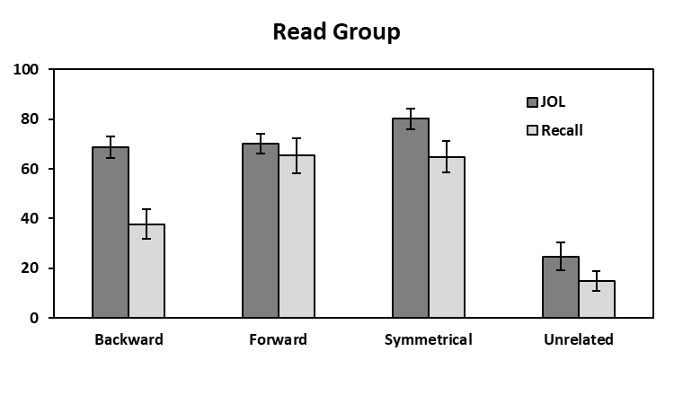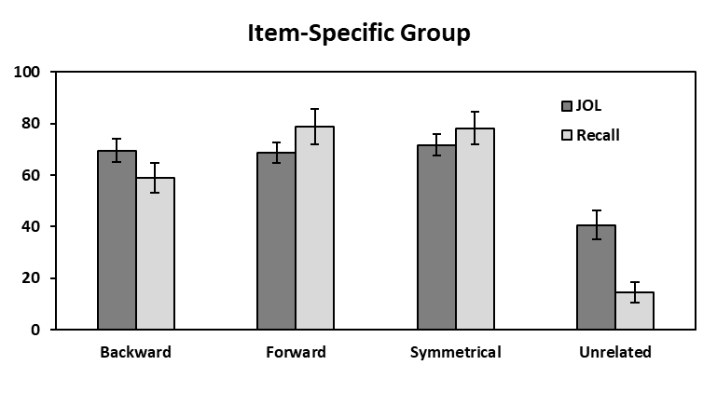

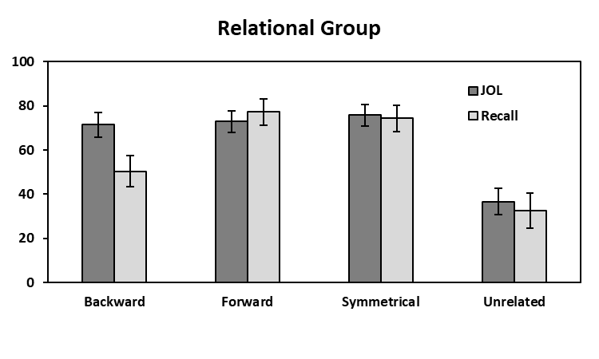

*Figure 1*. Mean JOL and recall rates as a function of pair type in the Read group (top panel), Item-Specific group (middle panel), and the Relational group (bottom panel in Experiment 1. Bars represent 95% confidence intervals.

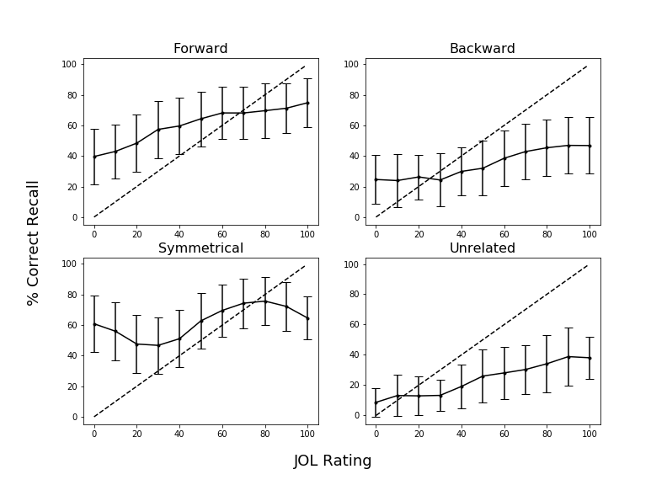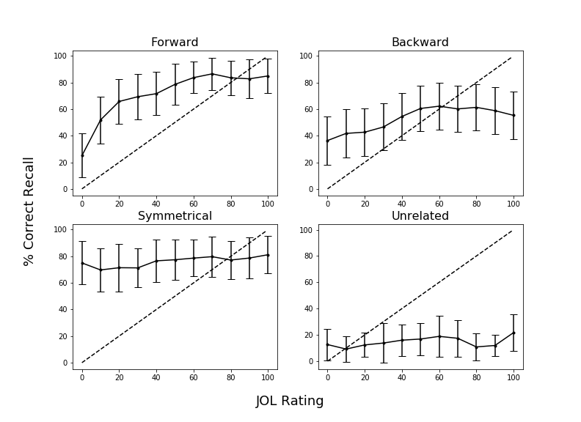

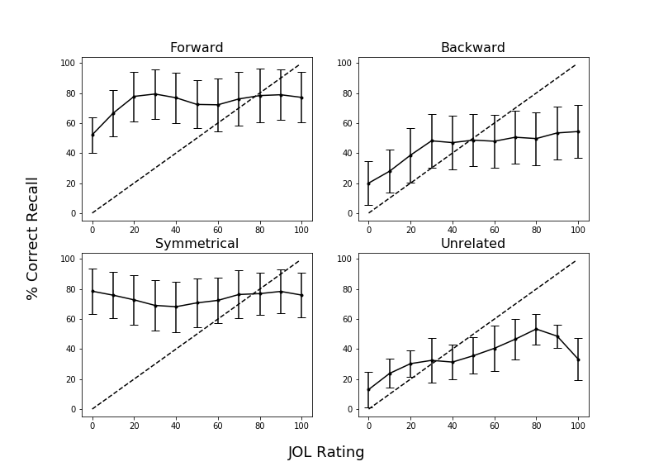

*Figure 2.* Calibration plots as a function of pair type in Experiment 1 for participants in the Read group (top panel), Item-Specific group (middle panel), and Relational group (bottom panel). Dashed lines indicate perfect calibration between JOL ratings and proportion of correct cued-recall. Overconﬁdence is represented by points falling below the calibration line. Data were smoothed over three adjacent JOL ratings. Bars represent 95% conﬁdence interval.

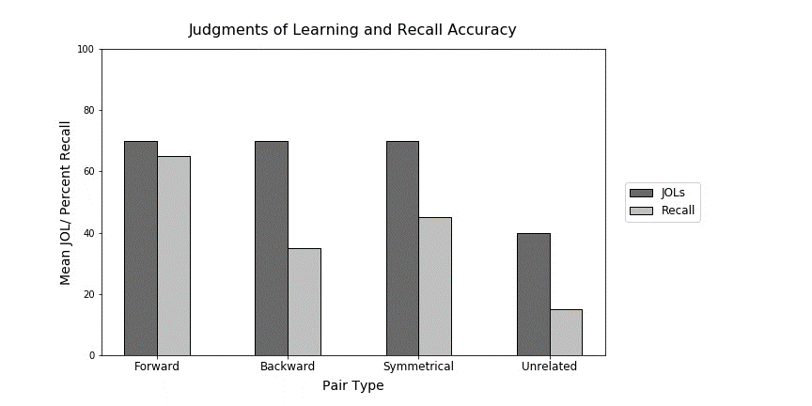

*Figure 3.* Sample data illustrating the illusion of competence for backward, symmetrical, and unrelated study pairs. This graph was provided to participants in the Experiment 2 warning group. Data pattern is modeled after Maxwell and Huff (in press).

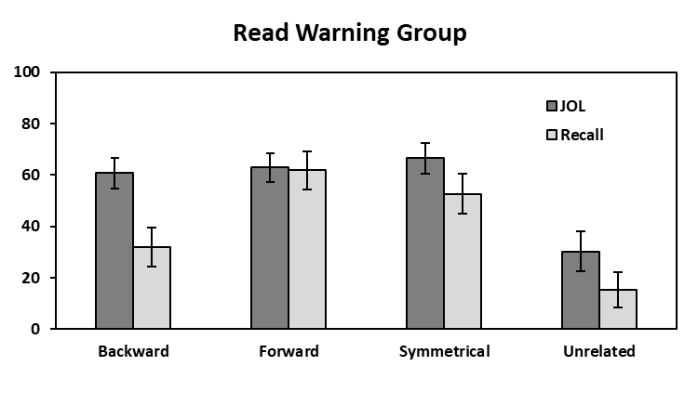 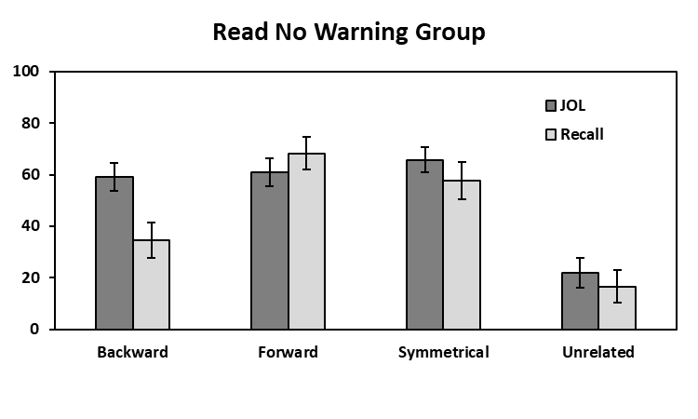

**Mean % JOL/Recall**

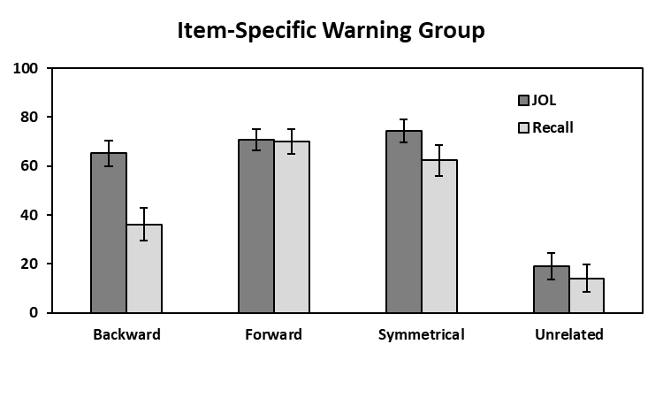 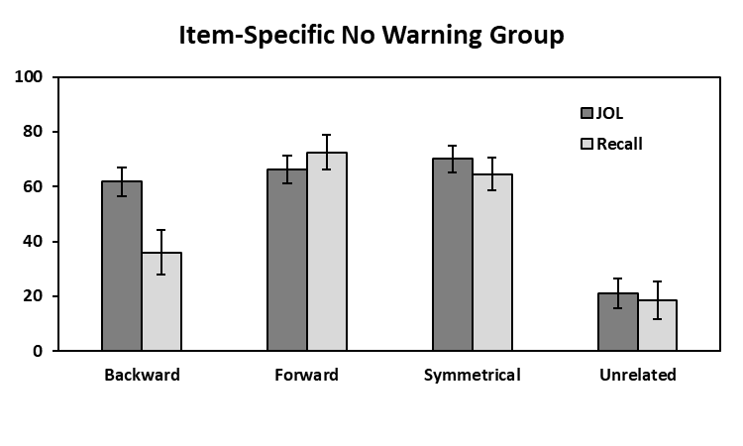

**Mean % JOL/Recall**

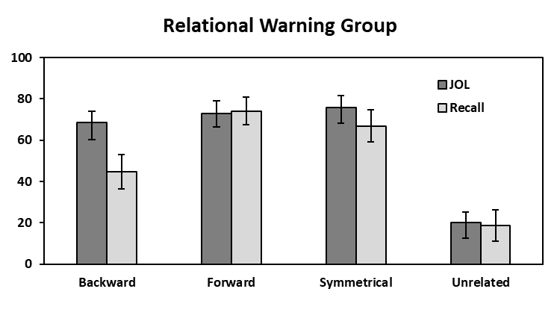 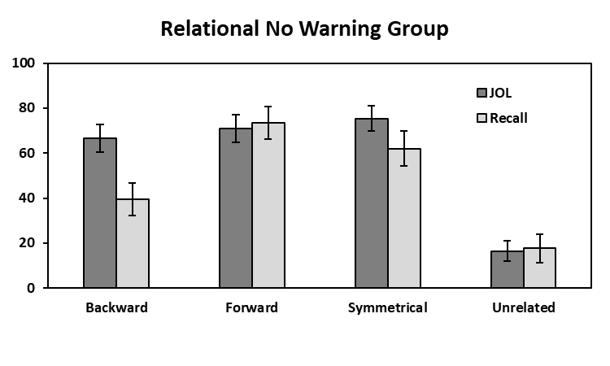

**Mean % JOL/Recall**

**Pair Type**

**Pair Type**

*Figure 4.* Mean JOL and recall rates as a function of pair type in the Read (top panels), Item-Specific (middle panels), and Relational (bottom panels) Warning and No Warning groups in Experiment 2. Bars represent 95% confidence intervals.

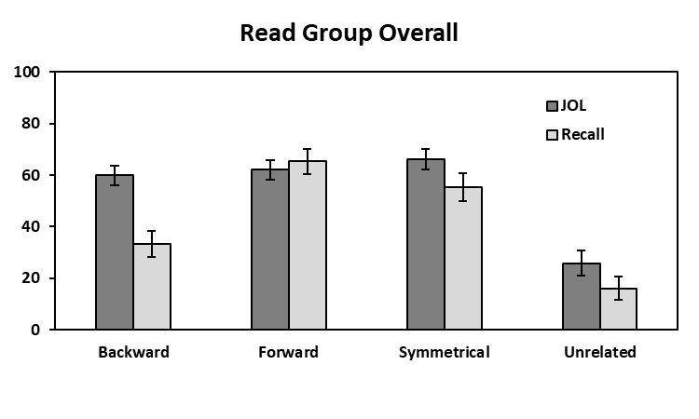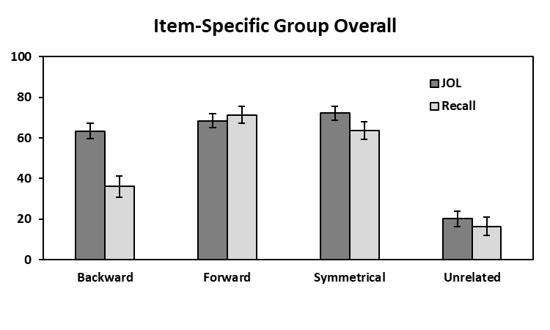

**Mean % JOL/Recall**

**Mean % JOL/Recall**

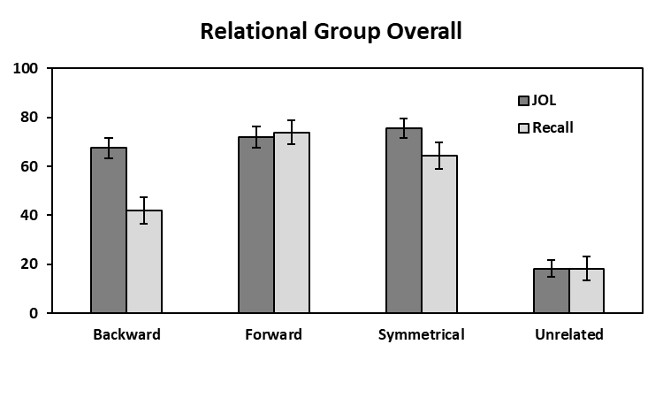

**Mean % JOL/Recall**

**Pair Type**

*Figure 5.* Mean JOL and recall rates as a function of pair type collapsed across warning for the read, item-specific, and relational groups in Experiment 2.

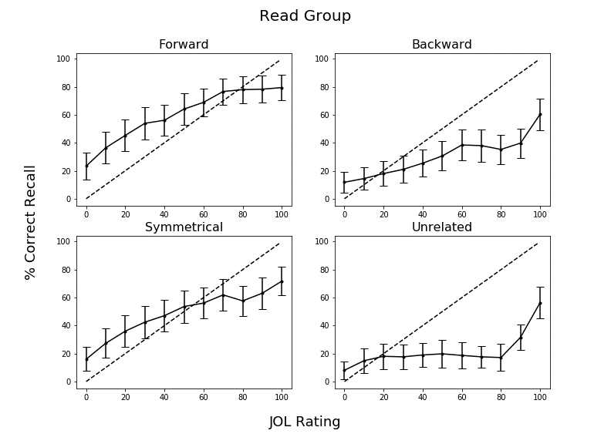

*Figure 6.* Calibration plots as a function of pair type in Experiment 2 for participants in the Read group for Block 2 recall collapsed across warning. Dashed lines indicate perfect calibration between JOL ratings and proportion of correct cued-recall. Overconﬁdence is represented by points falling below the calibration line. Data were smoothed over three adjacent JOL ratings. Bars represent 95% conﬁdence interval.

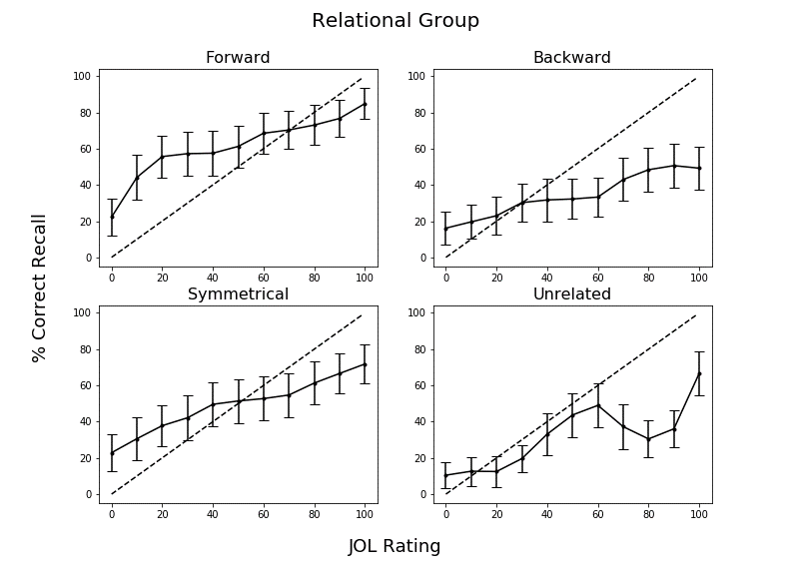

*Figure 7.* Calibration plots as a function of pair type in Experiment 2 for participants in the Relational group for Block 2 recall collapsed across warning. Dashed lines indicate perfect calibration between JOL ratings and proportion of correct cued-recall. Overconﬁdence is represented by points falling below the calibration line. Data were smoothed over three adjacent JOL ratings. Bars represent 95% conﬁdence interval.

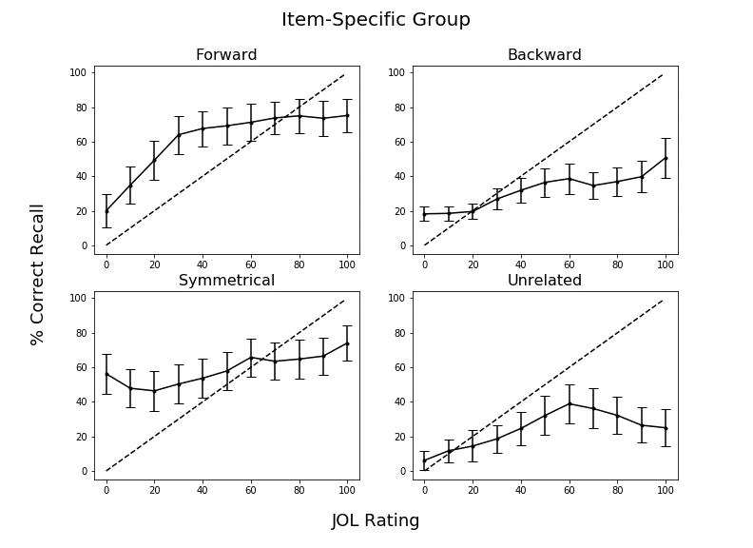

*Figure 8.* Calibration plots as a function of pair type in Experiment 2 for participants in the Item-Specific group for Block 2 recall collapsed across warning. Dashed lines indicate perfect calibration between JOL ratings and proportion of correct cued-recall. Overconﬁdence is represented by points falling below the calibration line. Data were smoothed over three adjacent JOL ratings. Bars represent 95% conﬁdence interval.

Table 1

|  |  |  |  |  |  |
| --- | --- | --- | --- | --- | --- |
| Condition | Variable | *M* | *SD* | *Min.* | *Max.* |
| Forward | FAS | .37 | .21 | .05 | .81 |
|  | BAS | .00 | .00 | .00 | .00 |
| Backward | FAS | .00 | .00 | .00 | .00 |
|  | BAS | .37 | .21 | .05 | .81 |
| Symmetrical | FAS | .19 | .13 | .01 | .46 |
|  | BAS | .19 | .13 | .02 | .52 |

*Mean Associative Strength Summary Statistics Forward, Backward, and Symmetrical Pairs.*

*Note.* FAS (forward associative strength) and BAS (backward associative strength) values for unrelated pairs as these items share zero associative overlap.

Table 2

*Summary Statistics for Cue and Target Concreteness, Length, and Frequency Item Properties as a Function of Pair Type.*

|  |  |  |  |  |
| --- | --- | --- | --- | --- |
| Pair Type | Position | Variable | *M* | *SD* |
| Forward | Cue | Concreteness | 4.97 | 1.22 |
|  |  | Length | 6.20 | 1.86 |
|  |  | Frequency | 3.74 | 0.67 |
|  | Target | Concreteness | 4.96 | 1.14 |
|  |  | Length | 4.46 | 1.27 |
|  |  | Frequency | 2.49 | 0.63 |
| Backward | Cue | Concreteness | 4.96 | 1.14 |
|  |  | Length | 4.46 | 1.27 |
|  |  | Frequency | 2.49 | 0.63 |
|  | Target | Concreteness | 4.97 | 1.22 |
|  |  | Length | 6.20 | 1.86 |
|  |  | Frequency | 3.74 | 0.67 |
| Symmetrical | Cue/Target | Concreteness | 4.70 | 1.38 |
|  |  | Length | 5.21 | 1.94 |
|  |  | Frequency | 3.23 | 0.67 |
| Unrelated | Cue/Target | Concreteness | 4.63 | 128 |
|  |  | Length | 5.21 | 1.52 |
|  |  | Frequency | 2.49 | 0.85 |

*Notes.* Frequency is measured using SUBTLEX word frequency measure (Brysbaert & New, 2009). Concreteness and length were taken from the English Lexicon Project (Balota et al., 2007).

1. Due to COVID-19 restrictions, the participants in Experiment 2 were sampled from both in-lab and online sources. The participant source was not found to interact with any of the results, *F*s < 1, though the vast majority of participants were recruited online. In-lab participants were tested using *E*-*Prime 3*, and online participants were tested using *Collector*, an open-source program for data collection on Psychology experiments (Garcia & Kornell, 2015). All procedural details and instructions were identical in both modalities, the only difference was the presence vs. absence of an experimenter.